**Text-Based AI Bot for**

**Monitoring Mental Health**

Project report submitted for

**4th Semester Minor Project-1**

**in**

**Department of Data Science and Artificial Intelligence**

By

**Aayush Dewangan (201020401)**

**Aryan Kaul (201020408)**

**Kunal Mahajan (201020427)**

**Under The Guidance of**

**Dr. Mallikharjuna Rao**



**Dr. Shyama Prasad Mukherjee  
Department of Data Science and Artificial Intelligence**

**International Institute of Information Technology, Naya Raipur**

**(A Joint Initiative of Govt. of Chhattisgarh and NTPC)**

**Email:** [**iiitnr@iiitnr.ac.in**](mailto:iiitnr@iiitnr.ac.in)**, Tel: (0771) 2474040, Web:** [**www.iiitnr.ac.in**](http://www.iiitnr.ac.in)

**CERTIFICATE**

This is to certify that the project titled “**Text-Based AI Bot for Monitoring Mental Health**” by “**Aayush Dewangan, Aryan Kaul, and Kunal Mahajan**” has been carried out under my/our supervision and that this work has not been submitted elsewhere for a degree/diploma.

(Signature of Guide)

___________________________________________

**Dr.Mallikharjuna Rao**

**Assistant Professor**

**Department of DSAI**

**Dr. SPM IIIT-NR**

**June 2022**

**Declaration**

Aayush Dewangan  
 Aryan Kaul  
 Kunal Mahajan

**Date: 2nd June 2022**

**Plagiarism Report**

**Approval Sheet**

This project report entitled “Text-Based AI Bot for Monitoring Mental Health” by “Aayush Dewangan, Aryan Kaul, and Kunal Mahajan” is approved for 4th Semester Minor Project-1.

(Signature of Examiner - I)

________________________

Name of Examiner -I

(Signature of Examiner - II)

________________________

Name of Examiner -II

(Signature of Chair)

________________________

Name of Chair

Date: 22/4/22 Place: ____________

**ABSTRACT**

Mental disorders can have a profound effect on the quality of life, are a major predictor of suicide, and are often undiagnosed and neglected. Early detection of symptoms of mental health problems is very important, as they are ignored, and they can put lives at risk. This is why a deeper understanding of the complex manifestations of the development of dementia is important. We present psychological research on the various datasets, according to different perspectives. We would like to understand whether language monitoring in these datasets can assist in the early detection of mental disorders, using machine learning models. In our solution, we have built in-depth learning models to learn the language symptoms of problems, at different levels of language (content, style, emotions), and to try to interpret the behavior of our models in order to better understand the symptoms of dementia. The use of chatbots changes the way health consumers and health workers communicate. Chatbot systems rely on algorithms to mimic convers. In our solution, we provide an overview of chatbot programs for mental health. Artificial intelligence is being misused in such systems to understand the natural language, create a personal conversation and make appropriate recommendations given to a particular user's voice and attitude. The potential benefits of chatbots have been demonstrated in terms of psychological training and adherence.

Keywords*:- Artificial Intelligence, Machine Learning, Natural Language Processing, Sentimental Analysis, Emotional Analysis, ChatBot, Mental Health.*

**Table of Contents**

**Title Page No.**

**ABSTRACT i**

**TABLE OF CONTENTS ii**

**LIST OF TABLES iii**

**LIST OF FIGURES iv**

**CHAPTER 1 INTRODUCTION 1**

**CHAPTER 2 LITERATURE REVIEW 3**

**CHAPTER 3 PROPOSED SOLUTION 10**

**CHAPTER 4 RESULTS 11**

**CHAPTER 5 CONCLUSIONS 14**

**REFERENCES 18**

**List of all the figures**

|  |  |  |
| --- | --- | --- |
| **Fig No.** | **Figure Title** | **Page Number** |
| 1 | Sentimental Analysis | 11 |
| 2 | Emotional Analysis | 11 |
| 3 | Rasa Working | 12 |
| 4 | Working of our solution | 15 |
| 5 | Android Application working | 16 |
| 6 | Rasa Working | 16 |
| 7 | Sentimental Analysis Working | 17 |
| 8 | Emotional Analysis Working | 18 |
| 9 | Result output analysis | 19 |
| 10 | Result output analysis | 19 |

**CHAPTER 1**

**INTRODUCTION**

Emotions are a complex expression of the senses which includes three categories: emotional event, psychological and physical reactions, as well as social or revealing reactions. A person's attitude is a condition of the opinion of that person and moreover gives a clue his general personality. Mental illness is the result of features lost in the science of the cerebrum. Depression is one of the most well-known and debilitating mental health problems and affects the community in a positive way. Depression and Schizophrenia is the main cause of most illnesses and suicide due to mental disorders. Many people are humiliated by depression while many are influenced by depression for many reasons. Psychological testing welfare is essential to understanding and uplifting the treatment of patients with dementia.

Mental health problems are an important and widespread public health problem. Depression mainly affects about 300 million people worldwide and is a major cause of suicide, making it the third leading cause of death among 10-24-year-olds. In addition, depression is poorly diagnosed and treated, and more than half of people with depression do not receive treatment. People suffering from mental retardation often hesitate to turn to a specialist for help in treating a disorder. However, more and more people are turning to social media to discuss their issues and seek emotional support[1].

Therefore, the need for automation is motivated not only by the inability to analyze the high amount of data generated on a daily basis in social media but also by the power of artificial intelligence to exploit large amounts of data to reveal clear psychological symptoms. the risk of complications, which can sometimes be difficult to detect even by the patient himself. According to, stress-based communication assessments reported so far in the literature may achieve predictive performance somewhere between untreated clinical trials and clinical trials. Data from social media, as a relatively rich and relatively simple type of data, as well as a growing source of real-time information, can thus be used to obtain many important details about human behavior and attitudes and their emergence. Statistical models that can accurately predict the development of dementia may be integrated into programs that have a significant impact on society as tools to warn users that they are at risk of having problems or chatbots. For physicians, an integrated analysis of mental health as reflected in social media data may provide data on a deeper understanding of mental disorders, and possibly lead to the development of advanced diagnostic tools.

In this project, we will be building a model which can analyze the mental health of a person using sentimental and emotional analysis where on the basis of the dataset, the model will be trained. As a final product, we will build an AI-based conversational bot, where the user can chat with the bot to check his/her emotions.

**CHAPTER 2**

**LITERATURE REVIEW**

In the meantime, picture the mental strength of a person, who writes on Twitter with a decrease in the development of tweets that show that a person, grieving and sending one of the alert words accustomed to tweeting and other words of the watch despair. See I found keywords about tweets from twitter.com using the application interface (API). See use keywords such as depression, anxiety, uncomfortable, tired, unfit, and many more to be collected from April to July 2022 on random days. We included more than 13k tweets in each of the above keywords or catchphrases to make their own examination.

At the calculation level, we aim to build a multi-dimensional text presentation in our database for accounting for different levels of language in which the symptoms of mental illness can produce. We extract various features from the text, which will be used as an input into our subsequent text separation models, and our other analysis in the following sections.

**2.1 Content features**

We include standard text representation content by translating each text into alphabetical order. The stored sequence will include the main recurring input and convolutional layers of our neural networks. Preliminary processing of texts includes punctuation and token production, as well as punctuation subjects and numbers. Shortcuts are not removed. Many 20,000 common words in all data sets are selected to form a common vocabulary. When transmitted as input to the neural network- functions, in-string words are encoded as embedded dimension 300. To start embedding weights- ding, we started with the pre-trained GloVe embedding. In Appendix, we add additional effects for our best model using some pre-trained embedding.

**2.2 Feelings and Emotions**

We offer a few features to answer- irritability and emotional content in our texts, from emotional the user's condition is known to be closely related to his or her mental health. Several LIWC stages are aimed at capturing emotions polarity and emotional content, from the ordinary, are the same negative emotions, positive emotions, affective processes, and more specific emotions, such as sadness and anxiety. We are used many other categories and created our own data dictionary, the NRC dictionary of emotions, viz dedicated specifically to emotional representation, which contains eight categories corresponding to the finest selection of emotions, based on Plutchik's eight basic senses: anger, anticipation, disgust, fear, joy, sadness, surprise, hope, and two more categories associated with evil and good emotions, respectively. We represent the features of the NRC equally LIWC features, such as number vectors for individual text ratings, as well as include all aspects of the NRC in the classification test. In our next analysis, when we try to test how reasonable we are styles deal with emotions for users with certain mental disorders, used only the NRC dictionary for emotions and kept The only LIWC lexicon to mark mental styles. Through the NRC the dictionary only works with physical emotions: negative (‘‘ Anger ’’, ‘‘ disgust ’’, ‘‘ fear ’’ and ‘‘ sadness ’’) and three good ones (‘‘ Happiness ’’, ‘‘ hope ’’, “joy” and ‘‘ expectation ’’), more than ‘‘ negative categories ’’ and ‘‘ good ’’ because in the context of the mental health these large groups offer a few ways to practice them in the clinic. For the same reason, we did not use ‘surprise’ as an emotion because it has no clear valence about positive or negative[2].

**2.3 Sentimental Analysis**

Sentiment analysis is a natural language processing technique used to determine the polarities of a text that can be positive, negative or neutral.

Without having any hesitation or awkwardness, humans will express their thoughts more frankly while chatting with a BoT. Sentiment analysis may become an essential tool for monitoring and understanding mental health.

Sentiment analysis can give a broad idea about the mental well-being of any person and can be beneficial in finding early symptoms of any mental illness.

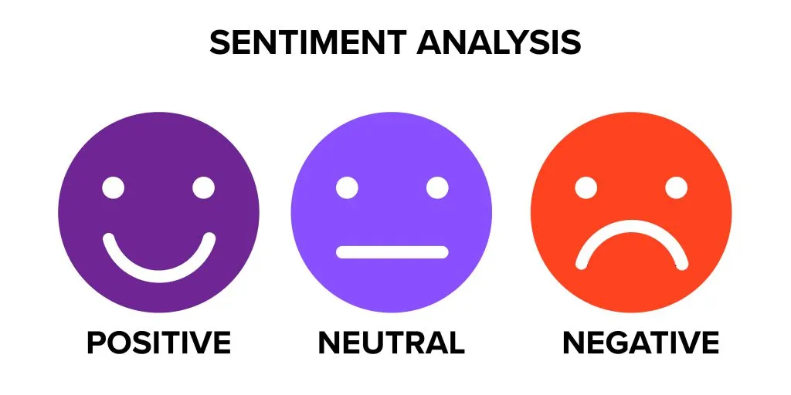

Fig. 1 Types of Sentiment [3]

**2.4 Emotional Analysis**

The Emotional analysis uses a much more complex system to understand consumer reactions. While sentimental analysis uses terms like positive or negative, emotional analysis focuses on a wide range of human emotions.

The emotional analysis will enhance the monitoring of the mental health of any person. This combination of emotional and sentimental analysis may acquire critical results for any mental illness.

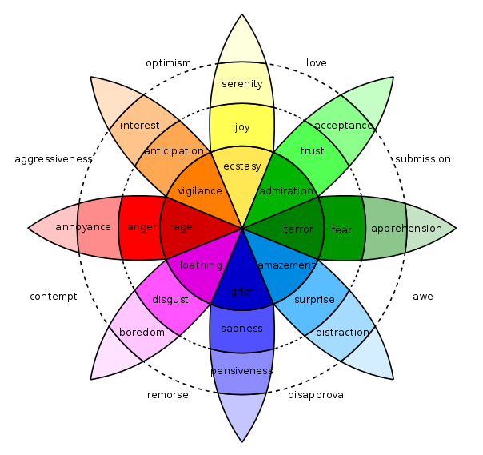

Fig. 2 Types of Emotion [4]

**2.5 Chatbot**

A chatbot is a system that works with users who use natural language in a variety of ways that include written, spoken, facial, and/or body language. The purpose of the chatbot system is to mimic a human conversation. Chatbots are usually text-driven and widgets integrated, making it easy to start communicating with a bot.

There are two types of chatbots:

i. Intellectual chatbots that generate dialogue based on predetermined rules or decision trees.

ii. Clever chatbots that use artificial intelligence (AI) to understand the context and purpose of utterance reactions.

**2.6 RASA**

Rasa is a software used to create customized AI chatbots using Python and natural language understanding (NLU). Rasa delivers a framework for developing AI chatbots that uses natural language understanding (NLU). It allows the user to train the model and add custom actions. Chatbots built using Rasa can be deployed on multiple platforms like FB messenger, Microsoft bot slack, etc.

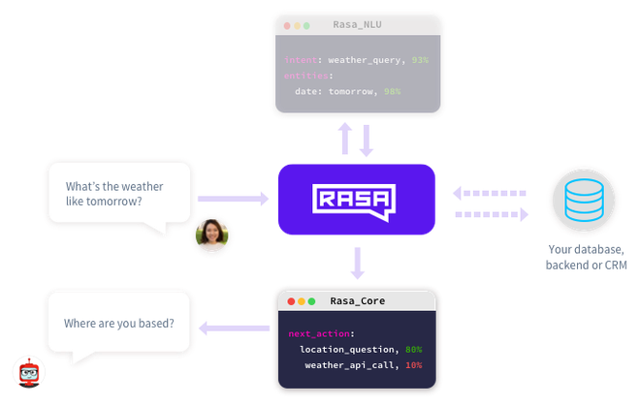

Fig. 3 Rasa Workflow [5]

Rasa comprises two main sections:

* **Rasa NLU (Natural Language Understanding):** Rasa NLU is an open-source natural language processing tool for understanding the crux of the sentence in a simplified manner. E.g., I am looking for a Chinese Restaurant in the middle of the town. From this sentence, the Rasa NLU will return

intent: search_restaurant

entities:

- cuisine: Chinese

- location: middle

Rasa NLU is essentially used to build chatbots and voice apps, which is called intent classification and entity extraction.

* **Rasa Core:** Rasa Core is the section in Rasa that manages dialogue management. Dialogue management is responsible for keeping a record of the conversation context and choosing the following actions accordingly.

In our solution, we have used Rasa to build our AI chatbot[6].

**2.7 Dataset description**

* Sentimental Analysis - Tweets Data

The dataset contain 13k tweets data with target label as positive and negative

* Emotional Analysis - Emotion Dataset for NLP

The dataset contains 9k sentence data with target label as eight different kind of emotions

* ChatBot Dataset

NLU - NLU training data stores structured information about user messages.

Stories - Stories are a type of training data used to train your assistant's dialogue management model.

Actions - After each user message, the model will predict an action that the assistant should perform next.

**2.8 Related Work**

There are a number of existing works related to mental health using sentimental analysis or emotional analysis. But the combination of sentimental and emotional analysis proves to give a more accurate result. The popular idea of ​​the chatbot was given by Weizenbaum, which was named Eliza. This work describes an ordinary human-machine conversation in language, which is a possible solution for building a chatbot.

Typically, support for people with psychological problems is done through face-to-face meetings with specific mental health professionals, typically psychologists and psychiatrists, with a frequency that could improve, as indicated by a review of cases, ranging from once per month to 3 times per week. Anyhow, since there is an increase of individuals with some type of mental problem, it is fundamental to accept the challenge of reducing or in any case slowing the growth of the number. One of the proposed solutions is the use of different patient assistance techniques provided through mobile phones and apps. Such strategies can be used to collect mental health data, and to motivate people to answer questions about what they do (or have done) and what they are experiencing (or have been). undergo) on a daily basis to perform a mental health-related intervention remotely, and to provide access to mental health assets, for example, to initiate communication channels Communicating with mental health professionals. this agreement is developed under the research area known as Mobile Health (mHealth).

But, nowadays with the advancement in technologies and facilities monitoring mental health is not at all a tough job. In this project, we have used natural language processing frameworks such as sentimental analysis and emotional analysis for predicting the mental health of an individual. We have made our own data dictionary for getting a more accurate result that could not be obtained with the available datasets on the internet.

**CHAPTER 3**

**PROPOSED SOLUTION**

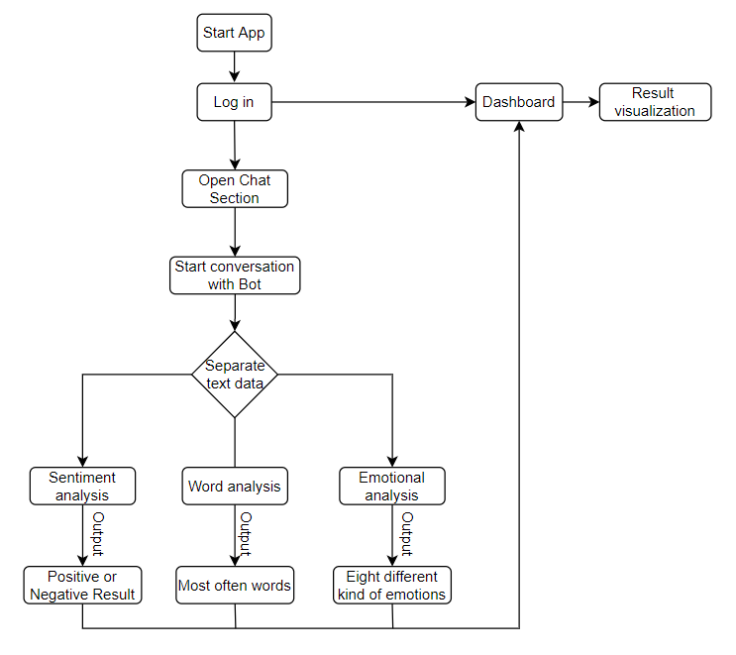

Fig. 4 Model Flow diagram

* This Block diagram gives the explanation that how a new user can use this analysis model.
* When an individual logs in using the chat app, he mainly has two options. First, go to dashboard for previous result visualization or start a new conversation

**3.1 Android application**

To develop the android application, we have used flutter, an open-source development kit created by google.

The user data are stored in the firebase which is a google based cloud service

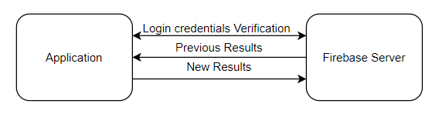 Fig 5 Android app workflow [7]

**3.2 Rasa Workflow**

In our solution, we have used Rasa. Rasa NLU simplifies the sentence entered from the application into short phrases. Later, the message is sent to the backend and processed in the NLU Pipeline model in terms of tokens and features, classified based on the data stored in the cloud. Later, the result is shown based on how the user is happy, sad, or angry in terms of emotion and positive, negative, or neutral sentiment.

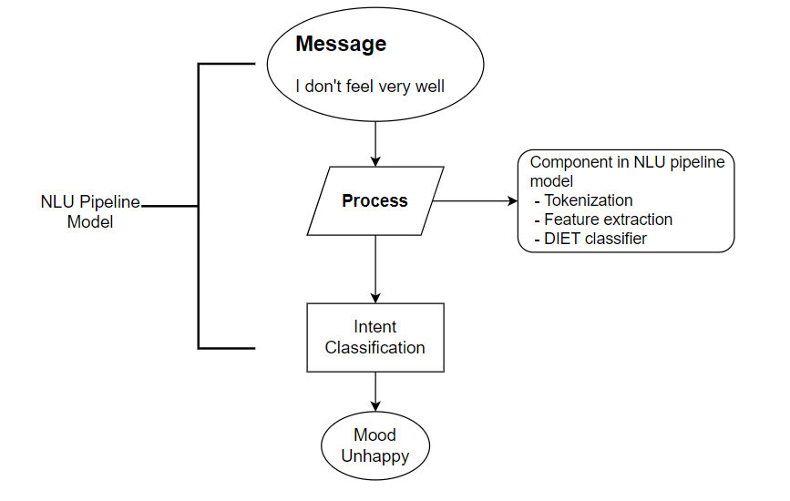

Fig. 6 Rasa NLU pipeline workflow [8]

**3.3 Sentimental Analysis**

Sentiment analysis is the study of determining if a given text is positive, negative, or neutral In our chatbot, we have used the concept of sentimental analysis. The most crucial thing for a person suffering from mental is their sentiment and their emotion since those two factors determine the majority of the mental health. Our chatbot gives an accurate result for the sentimental analysis of the user so that they can visit a psychiatrist as soon as possible in case of severe mental health.

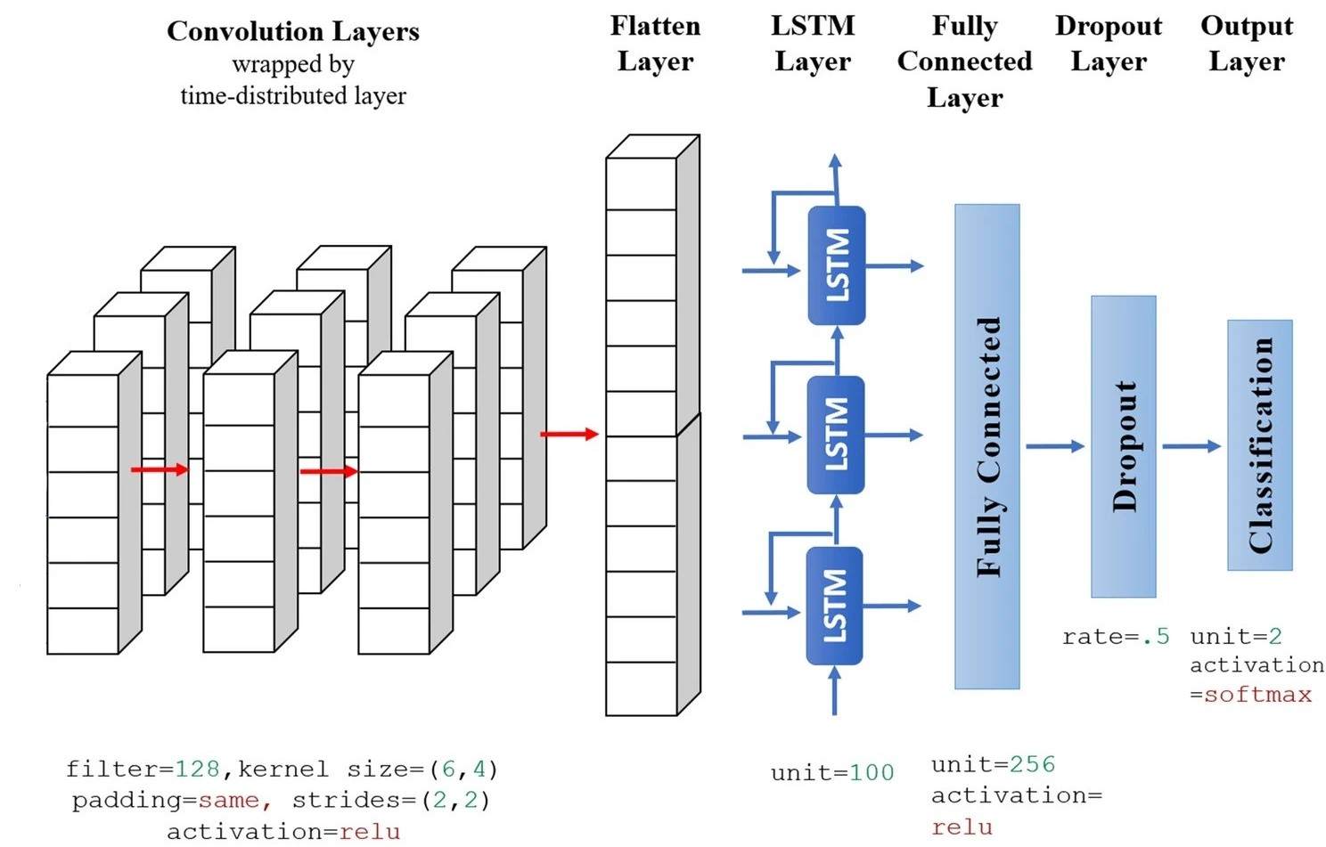

Fig. 7 LSTM workflow [10]

**3.4 Emotional Analysis**

Emotional analysis examines the emotions expressed in the sentence in the form of textual data. This data comes in the form of a pie chart on the dashboard once the conversation with the user is over.

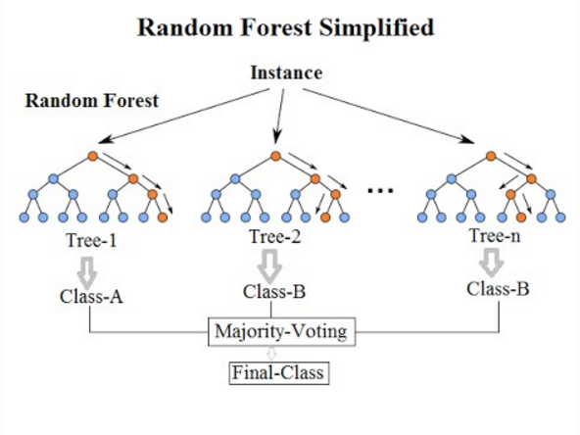

Fig. 8 Random Forest workflow [11]

**3.5 Dashboard**

A data dashboard is a tool that provides a centralized, interactive means of analyzing, measuring, and extracting relevant insights from the different models while displaying information in an interactive, intuitive, and visual way[12].

In our chatbot, after the conversation, the result of the conversation will be displayed on the dashboard. A pie chart will be represented in terms of sentiments and emotions, and for the most often words used, a histogram will be shown on the dashboard. Our dashboard gives us a complete overview of what’s happening with your chatbots and ongoing chats.

**CHAPTER 4**

**RESULTS**

**4.1 Chatbot app**

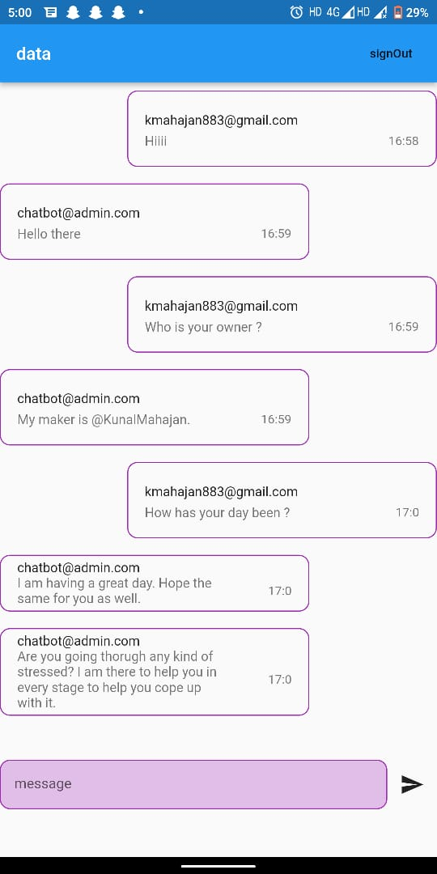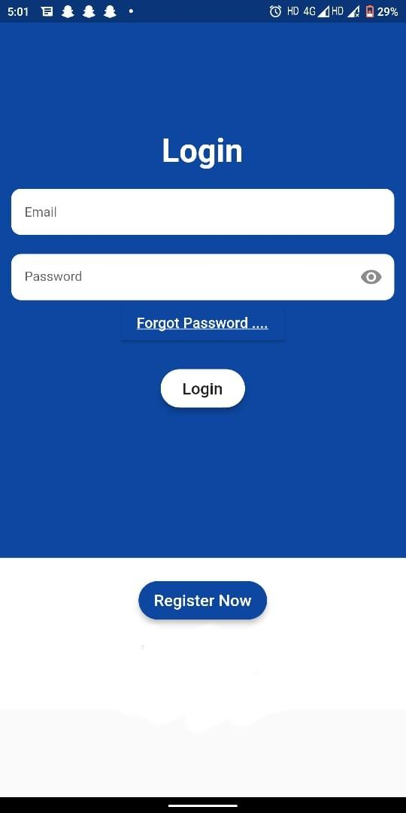

* This is a snippet of our user-friendly chatbot.
* The app uses Rasa NLU to give responses according to user input and can perform actions.
* The chat text data is then analysed for the sentimental and emotional analysis.

**4.2 Model Evaluation Score**

|  |  |  |  |
| --- | --- | --- | --- |
| Model | F1 - Score | Accuracy | Precision |
| NLU Pipeline | 0.826 | 82.7 | 0.849 |
| LSTM | 0.875 | 87.5 | 0.875 |
| Random forest classifier | 0.79 | 80 | 0.77 |

The Above table shows the evaluation scores of different models used in this project, The NLU pipeline model for chatbot, LSTM model for Sentimental Analysis and Random Forest Classifier for emotion classification.

**4.3 Model Resul Visualization**

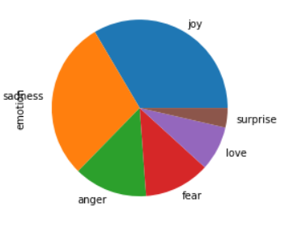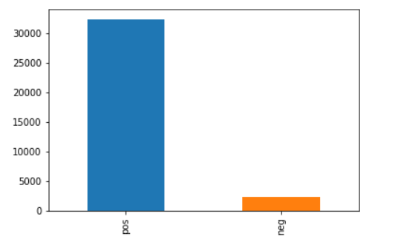

Fig. 9 Emotional Analysis Fig. 10 Sentiment Analysis

The DashBoard Output of our chatbot can be understood from the above figure, where the emotional analysis model predicts different types of emotions on the basis of chat data. Now taking into consideration the sentimental analysis we can see that the model predicts the sentiment of an individual as positive or negative.

**CHAPTER 5**

**CONCLUSION**

Mental health stability incorporates an individual's psychological, emotional, and social prosperity. It is crucial in every stage of life since it affects how one thinks, feels, and acts. It is considered healthy to visit a therapist occasionally to keep a person's mental health stable. Many people have a mental illness but fail to notice it as they are too busy to visit a therapist. Chatbot for Monitoring Mental health is mainly developed to keep track of people's mental health. Users can use this once or twice a week, as per the user's requirement. Our application is of great help to the user. It helps the user to identify the problem and gives consultancy as well. Firstly, one will open our application and go login into their account. Then the user will go on to the chatting section, where they will be interacting with the bot. After starting a conversation with the bot, the user's texts will be classified into three different domains based on emotional analysis, sentimental analysis, and the analysis of the words that have been used. Our application has the data of the terms used in the users' conversations with the bot. After all the investigations, our application will give a pie chart of the response, the emotion they are going through, and the sentimental analysis. All this will be presented on the dashboard of the application at the end as a summary of the conversation they have had with the bot. It hardly takes 5-10 minutes to have a conversation with the chatbot, which the chatbot will process. If the user’s mental health is severe or extremely severe based on the application score, then the chatbot will suggest the user to visit a psychiatrist as soon as possible. If the result is mild or moderate, then the chatbot will offer some activities to perform by the user to take care of their mental health. Using this saves time for the user and helps users keep track of their mental health.

**CHAPTER 6**

**REFERENCES**

1. “International markets and contexts” By Michael Colebourne

1. National Center for Biotechnology Information.Information about Mental Illness and the Brain.
2. Gururaj G, Varghese M, Benegal V, Rao GN, Pathak K, Singh LK, et al. Bengaluru: National Institute of Mental Health and Neurosciences; 2016. National Mental Health Survey of India, 2015-16
3. V. Laijawala et al. “Classification Algorithms based mental Health Prediction using Data Mining”. In: 20205th International Conference on Communication and Electronics Systems (ICCES).
4. GeeksforGeeks “Chatbots using Rasa and Python” -28th December 2021
5. Stackoverflow “Difference between Rasa core and Rasa nlu” -January,2017
6. V. Mody and V. Mody, "MentalHealth Monitoring System using Artificial Intelligence: A Review," 2019 IEEE 5th International Conference for Convergence in Technology (I2CT), Bombay, India, 2019, p
7. World Health Organisation. Geneva, Switzerland: World Health Organisation; 2006. [2019-11-12]. Constitution of the World Health Organisation <https://www.who.int/governance/eb/who_constitution_en.pdf>.
8. Denecke K, Deng Y. Sentiment analysis in medical settings: new opportunities and challenges. Artif Intell Med.

1. E. Pratt, “A Primer Artificial Intelligence and Chatbots in Technical Communication – A Primer,” pp. 2–9, 2017.
2. Random Forest Simple Explanation- Understanding the Random Forest with an intuitive example. https://williamkoehrsen.medium.com/
3. Inkster B, Sarda S, Subramanian V (2018) An Empathy-Driven, Conversational Artificial Intelligence Agent (Wysa) for Digital Mental Well-Being: Real-World Data Evaluation Mixed-Methods Study. JMIR Mhealth Uhealth
4. An Introduction To Data Dashboards: Meaning, Definition & Industry Examples
5. WHO. Mental disorders affect one in four people. https://www.who.int/whr/2001/mediacentre/pressrel ease/en/.Last accessed 27 July 2020.
6. https://www.kaggle.com/datasets/gargmanas/sentimental-analysis-for-tweets
7. https://www.kaggle.com/datasets/praveengovi/emotions-dataset-for-nlp